**OPERATING SYSTEM PROJECT**

**(GROUP1 )**

**PROBLEM STATEMENT :**

Dynamic Implementation Of FCFS System .

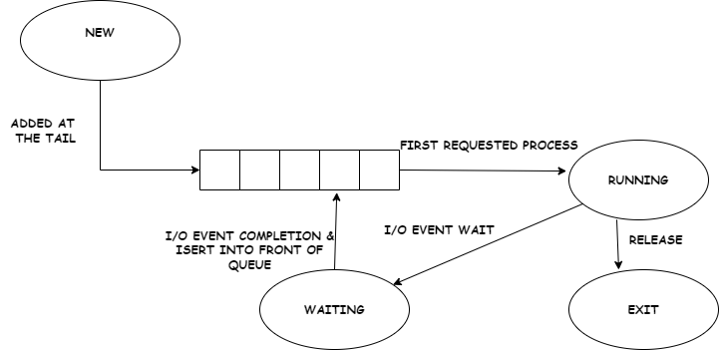

DETAILED OVERVIEW OF PROBLEM STATEMENT :

Given n processes with their burst times , the task is to find average waiting time and average turn around time using FCFS scheduling algorithm .

**BASIC TERMINOLOGIES :**

1. FILO (first in first out ) , also known as , first come first serve(FCFS)

Is the simplest scheduling algorithm . It simply queues processes in the order that they arrive in the ready queue . Processes that come first will be executed first and the next process starts only after the previous gets fully executed .

1. COMPLETION TIME : Time at which process completes its execution

1. TURN AROUND TIME : Time difference between completion time and arrival time .

Turn around time = completion time – Arrival Time

1. WAITING TIME : Time difference between turn around time and burst time .

Waiting time = Turnaround time – Burst time

* ADVANTAGES : 1. User Friendly

2. Easy to implement

3. Simple

* DISADVANTAGES : 1. Long waiting time

2. Lower device utilization

3. Not ideal for time sharing systems